//Nachiket Ropia

//21070126056

import java.util.\*;  
  
abstract class shape{  
 int s,l,h,b,r;  
 double area,perimeter,volume;  
  
 Scanner sc = new Scanner(System.*in*);  
  
  
 abstract void getdata();  
 abstract void calculatearea();  
 abstract void calculateperimeter();  
 abstract void display();  
 abstract void calculateVolume();  
  
}  
class square extends shape{  
 void getdata(){  
 System.*out*.println("Enter the side length");  
 s = sc.nextInt();  
 }  
 void calculatearea(){  
 area = s \* s;  
 }  
 void calculateperimeter(){  
 perimeter = 4\*s;  
 }  
 void display(){  
 System.*out*.println("The area is " + area);  
 System.*out*.println("The perimeter is" + perimeter);  
 System.*out*.println("Square has no volume");  
 }  
 void calculateVolume(){}  
}  
class circle extends shape{  
 void getdata(){  
 System.*out*.println("Enter radius");  
 r =sc.nextInt();  
 }  
 void calculatearea(){  
 area = (r\*r)\*Math.*PI*;  
 }  
 void calculateperimeter(){  
 perimeter = (2\*r)\*Math.*PI*;  
 }  
 void display(){  
 System.*out*.println("The area is " + area );  
 System.*out*.println("The perimeter is " + perimeter );  
 System.*out*.println("Circle has no volume");  
 }  
 void calculateVolume(){}  
}  
class rectangle extends shape {  
 void getdata(){  
 System.*out*.println("Enter the length ");  
 l = sc.nextInt();  
 System.*out*.println("Enter the breadth");  
 b = sc.nextInt();  
 }  
 void calculatearea(){  
 area = b \* l;  
 }  
 void calculateperimeter(){  
 perimeter = 2\*(l \* b);  
 }  
 void display(){  
 System.*out*.println("The area is " + area );  
 System.*out*.println("The perimeter is " + perimeter );  
 System.*out*.println("Rectangle has no volume");  
 }  
 void calculateVolume(){}  
}  
class cylinder extends shape {  
 void getdata(){  
 System.*out*.println("Enter the height ");  
 h = sc.nextInt();  
 System.*out*.println("Enter the radius");  
 r = sc.nextInt();  
 }  
 void calculatearea(){  
 area = 2\*Math.*PI*\*r\*(r+h);  
 }  
 void calculateperimeter(){}  
 void calculateVolume(){  
 volume = Math.*PI* \* (r \* r \* h);  
 }  
 void display(){  
 System.*out*.println("The area is " + area );  
 System.*out*.println("The volume is" + volume);  
 }  
}  
class sphere extends shape {  
 void getdata(){  
 System.*out*.println("Enter the radius");  
 r = sc.nextInt();  
 }  
 void calculatearea(){  
 area = 4\*Math.*PI*\*r\*r;  
 }  
 void calculateperimeter(){}  
 void calculateVolume(){  
 volume = 1.33\*Math.*PI* \* r \* r \* r;  
 }  
 void display(){  
 System.*out*.println("The area is " + area );  
 System.*out*.println("The volume is" + volume);  
 }  
  
}  
class pyramid extends shape {  
 void getdata(){  
 System.*out*.println("Enter the length");  
 l = sc.nextInt();  
 System.*out*.println("Enter the height");  
 h = sc.nextInt();  
 }  
 void calculatearea(){  
 }  
 void calculateperimeter(){}  
 void calculateVolume(){  
 volume = (l\*l\*h)\*0.333;  
 }  
 void display(){  
 System.*out*.println("The volume is" + volume);  
 }  
}  
class Main{  
 public static void main(String[] args) {  
 Scanner bc = new Scanner(System.*in*);  
 System.*out*.println("Enter 1 for square ");  
 System.*out*.println("Enter 2 for rectangle");  
 System.*out*.println("Enter 3 for triangle ");  
 System.*out*.println("Enter 4 for cylinder ");  
 System.*out*.println("Enter 5 for sphere ");  
 System.*out*.println("Enter 6 for pyramid ");  
  
 int choice = bc.nextInt();  
 switch (choice){  
 case 1 :  
 System.*out*.println("Square");  
 square s = new square();  
 s.getdata();  
 s.calculatearea();  
 s.calculateperimeter();  
 s.display();  
 case 2 :  
 System.*out*.println("Rectangle");  
 rectangle r = new rectangle();  
 r.getdata();  
 r.calculatearea();  
 r.calculateperimeter();  
 r.display();  
 case 3 :  
 System.*out*.println("Circle");  
 circle t = new circle();  
 t.getdata();  
 t.calculatearea();  
 t.calculateperimeter();  
 t.display();  
 case 4 :  
 System.*out*.println("Cylinder");  
 cylinder cy = new cylinder();  
 cy.getdata();  
 cy.calculatearea();  
 cy.display();  
 cy.calculateVolume();  
 case 5 :  
 System.*out*.println("Sphere");  
 sphere sp = new sphere();  
 sp.getdata();  
 sp.calculatearea();  
 sp.display();  
 sp.calculateVolume();  
 case 6 :  
 System.*out*.println("Pyramid");  
 pyramid p = new pyramid();  
 p.getdata();  
 p.calculatearea();  
 p.display();  
 p.calculateVolume();  
  
 }  
 }  
}

Results

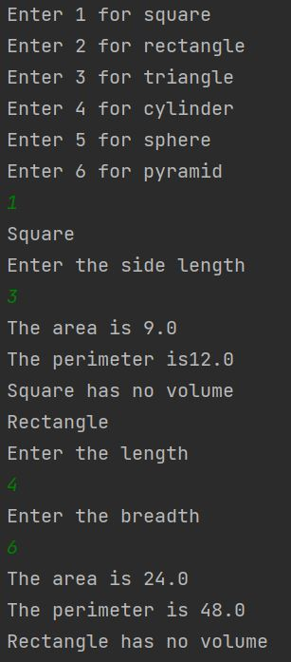

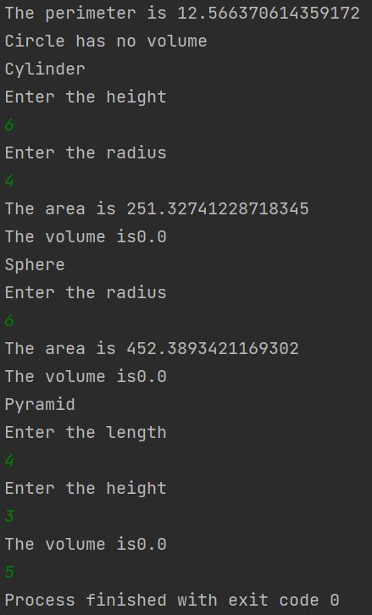

Github link -

https://github.com/NachiketRopia2003/Java-Assignment/tree/main/Assignment%201